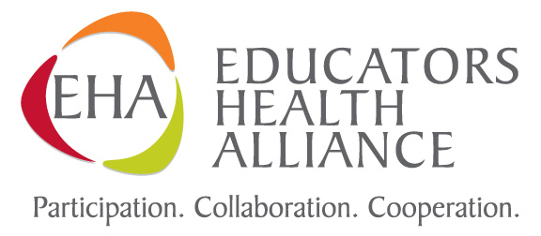

Board Approves Educators Health Alliance 2014-15 Rates and Benefits

EHA premium rates for the Blue Cross and Blue Shield of Nebraska (BCBSNE) health care plan used by nearly every Nebraska school district will increase by 2.3 percent for all benefit options on Sept. 1, 2014. The Board of Directors of the Educators Health Alliance approved the renewal rates and benefits on Monday, Oct. 12, 2013.

When the 2014-15 plan year starts on Sept. 1, 2014, it will mark the 12th consecutive year the rate increases have been less than 10 percent. The rate increases in 2011-12, 2012-13 and 2013-14 were 0.0 percent, 2.99 percent and 6.4 percent respectively. The EHA has kept the increases well below national trends.

“Several factors contributed to the EHA’s ability to achieve a rate increase below medical inflation,” said Neal Clayburn, EHA board chair. “The wise use of medical services and maintenance of healthy practices by our members has resulted in favorable claim experience. Additional factors include the work of BCBSNE, the dependent eligibility verification recently completed, and the collaboration of the three associations that govern the plan: the Nebraska School Boards Association, Nebraska Council of School Administrators and the Nebraska State Education Association.”

Rates will increase by 2.3 percent for all rates and benefit categories. This includes all medical and dental plans as well as active employee and early retiree categories.

The Affordable Care Act (ACA) continues to be an important consideration in the development of the EHA health insurance renewal of rates and benefits.

- Currently the medical and pharmacy benefits have separate out of pocket maximums and the non-pharmacy copays are applied without limit. As a result of the ACA, the out of pocket maximum expense for all services will be combined into a single maximum amount effective Sept. 1, 2014. This amount will be lower than the current combined amounts for medical and pharmacy.

- The renewal rates include the additional fees and taxes required by the ACA, including the Insurer Excise Tax, the Transitional Reinsurance Fee, and the Patient Centered Outcomes Research Institute (PCORI) fee.

- The $5,000 deductible plan offering will be eliminated as it does not meet the ACA “minimum value” definition.

- Early retirees will receive a one month, 65 percent reduction in their current premium rate to be applied for the month of December 2013 only. This reduction is made possible by funds the EHA obtained under the Early Retiree Reinsurance Program (ERRP).

“The EHA continues to work diligently to achieve rate stability and increases below health insurance industry averages,” said Clayburn. “In addition to good management of the plan, utilization substantially affects rates. Our members are making smart health care choices and that is reflected in continued favorable experience with regard to utilization.”

The Board also approved a change to take effect on Sept. 1, 2015, that expands the definition of eligible dependent to include domestic partners and their children. To qualify, the subscriber and his/her domestic partner must meet specific criteria and provide certification of the domestic partnership. Additional information regarding this change is available at http://www.ehaplan.org/.*

The EHA plan’s insurance coverage with Blue Cross Blue Shield of Nebraska includes more than 70,000 education employees, early retirees and their dependents in more than 400 school groups. NSEA formed the statewide health care network 45 years ago. A 12-member board representing NSEA, the Nebraska Association of School Boards and the Nebraska Council of School Administrators now governs the health care plan.

-end-

*The EHA Board rescinded this decision at the July 21, 2014 meeting and endorsed the BCBSNE policy to expand coverage to legally married couples, including same-sex legal marriages.

